*Screen Specification*

**Rush Order Screen**

* Date created: 04/11/2021
* Person in charge: Hoàng Mai Đức Long

1. Screen sample view

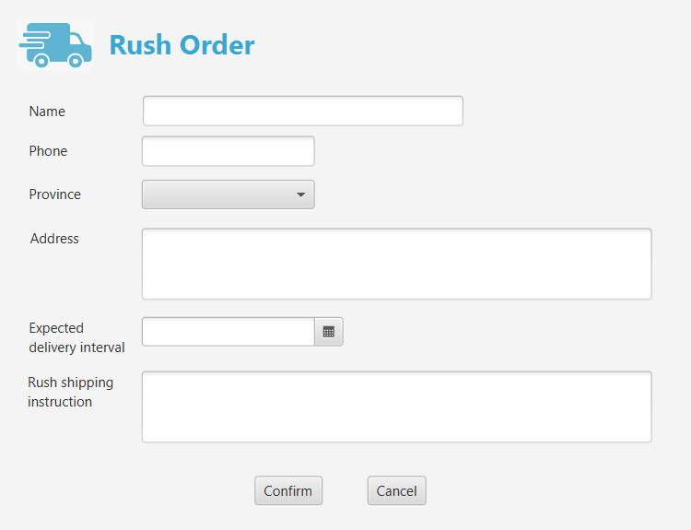

1. Screen specification

|  |  |  |
| --- | --- | --- |
| **Control** | **Operation** | **Function** |
| Areas to input rush order information | Input | Input rush order information |
| Confirm button | Click | Submit inputted information |
| Cancel button | Click | Cancel placing rush order process and return to Delivery Form |

1. Field specificaition

|  |  |  |
| --- | --- | --- |
| **Field** | **Type** | **Remark** |
| Name | String input | Auto import from Delivery Form |
| Phone | Auto import from Delivery Form |
| Address | Auto import from Delivery Form |
| Rush Shipping instruction |  |
| Province | Drop down list | Auto import from Delivery Form |
| Expected delivery interval | Numerical input |  |